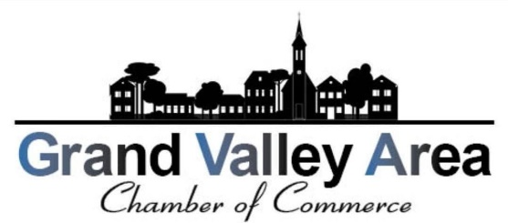
Dear Chamber Member,
Its time to renew your annual membership to the Grand Valley Area Chamber of Commerce! Please complete the form below and return it no later then December 15th 2025 to make sure you still receive your exclusive member benefits as well as continue receiving communications and updates from the Chamber. We would not be where we are today without your continued support. We appreciate every single one of you and look forward to another fun, strong, and successful year! Please note the changes to the membership fees below.

2026 Membership Renewal Form

Business Name:
Contact
Person & Title
Email
Phone
Payment Tier:
Non-Profit: $40
20 Employees or less $50
21-50 Employees $60
51 or more employees $75

You can mail this form and your payment to:
GVACC PO Box 261 Orwell, Ohio 44076
OR
Stop in the GV Public Library to drop off your application along with your payment to Jackie Foote




For any questions, please email us at: gvaccinfo440@gmail.com

